Manual Plate Sealer---MSP200
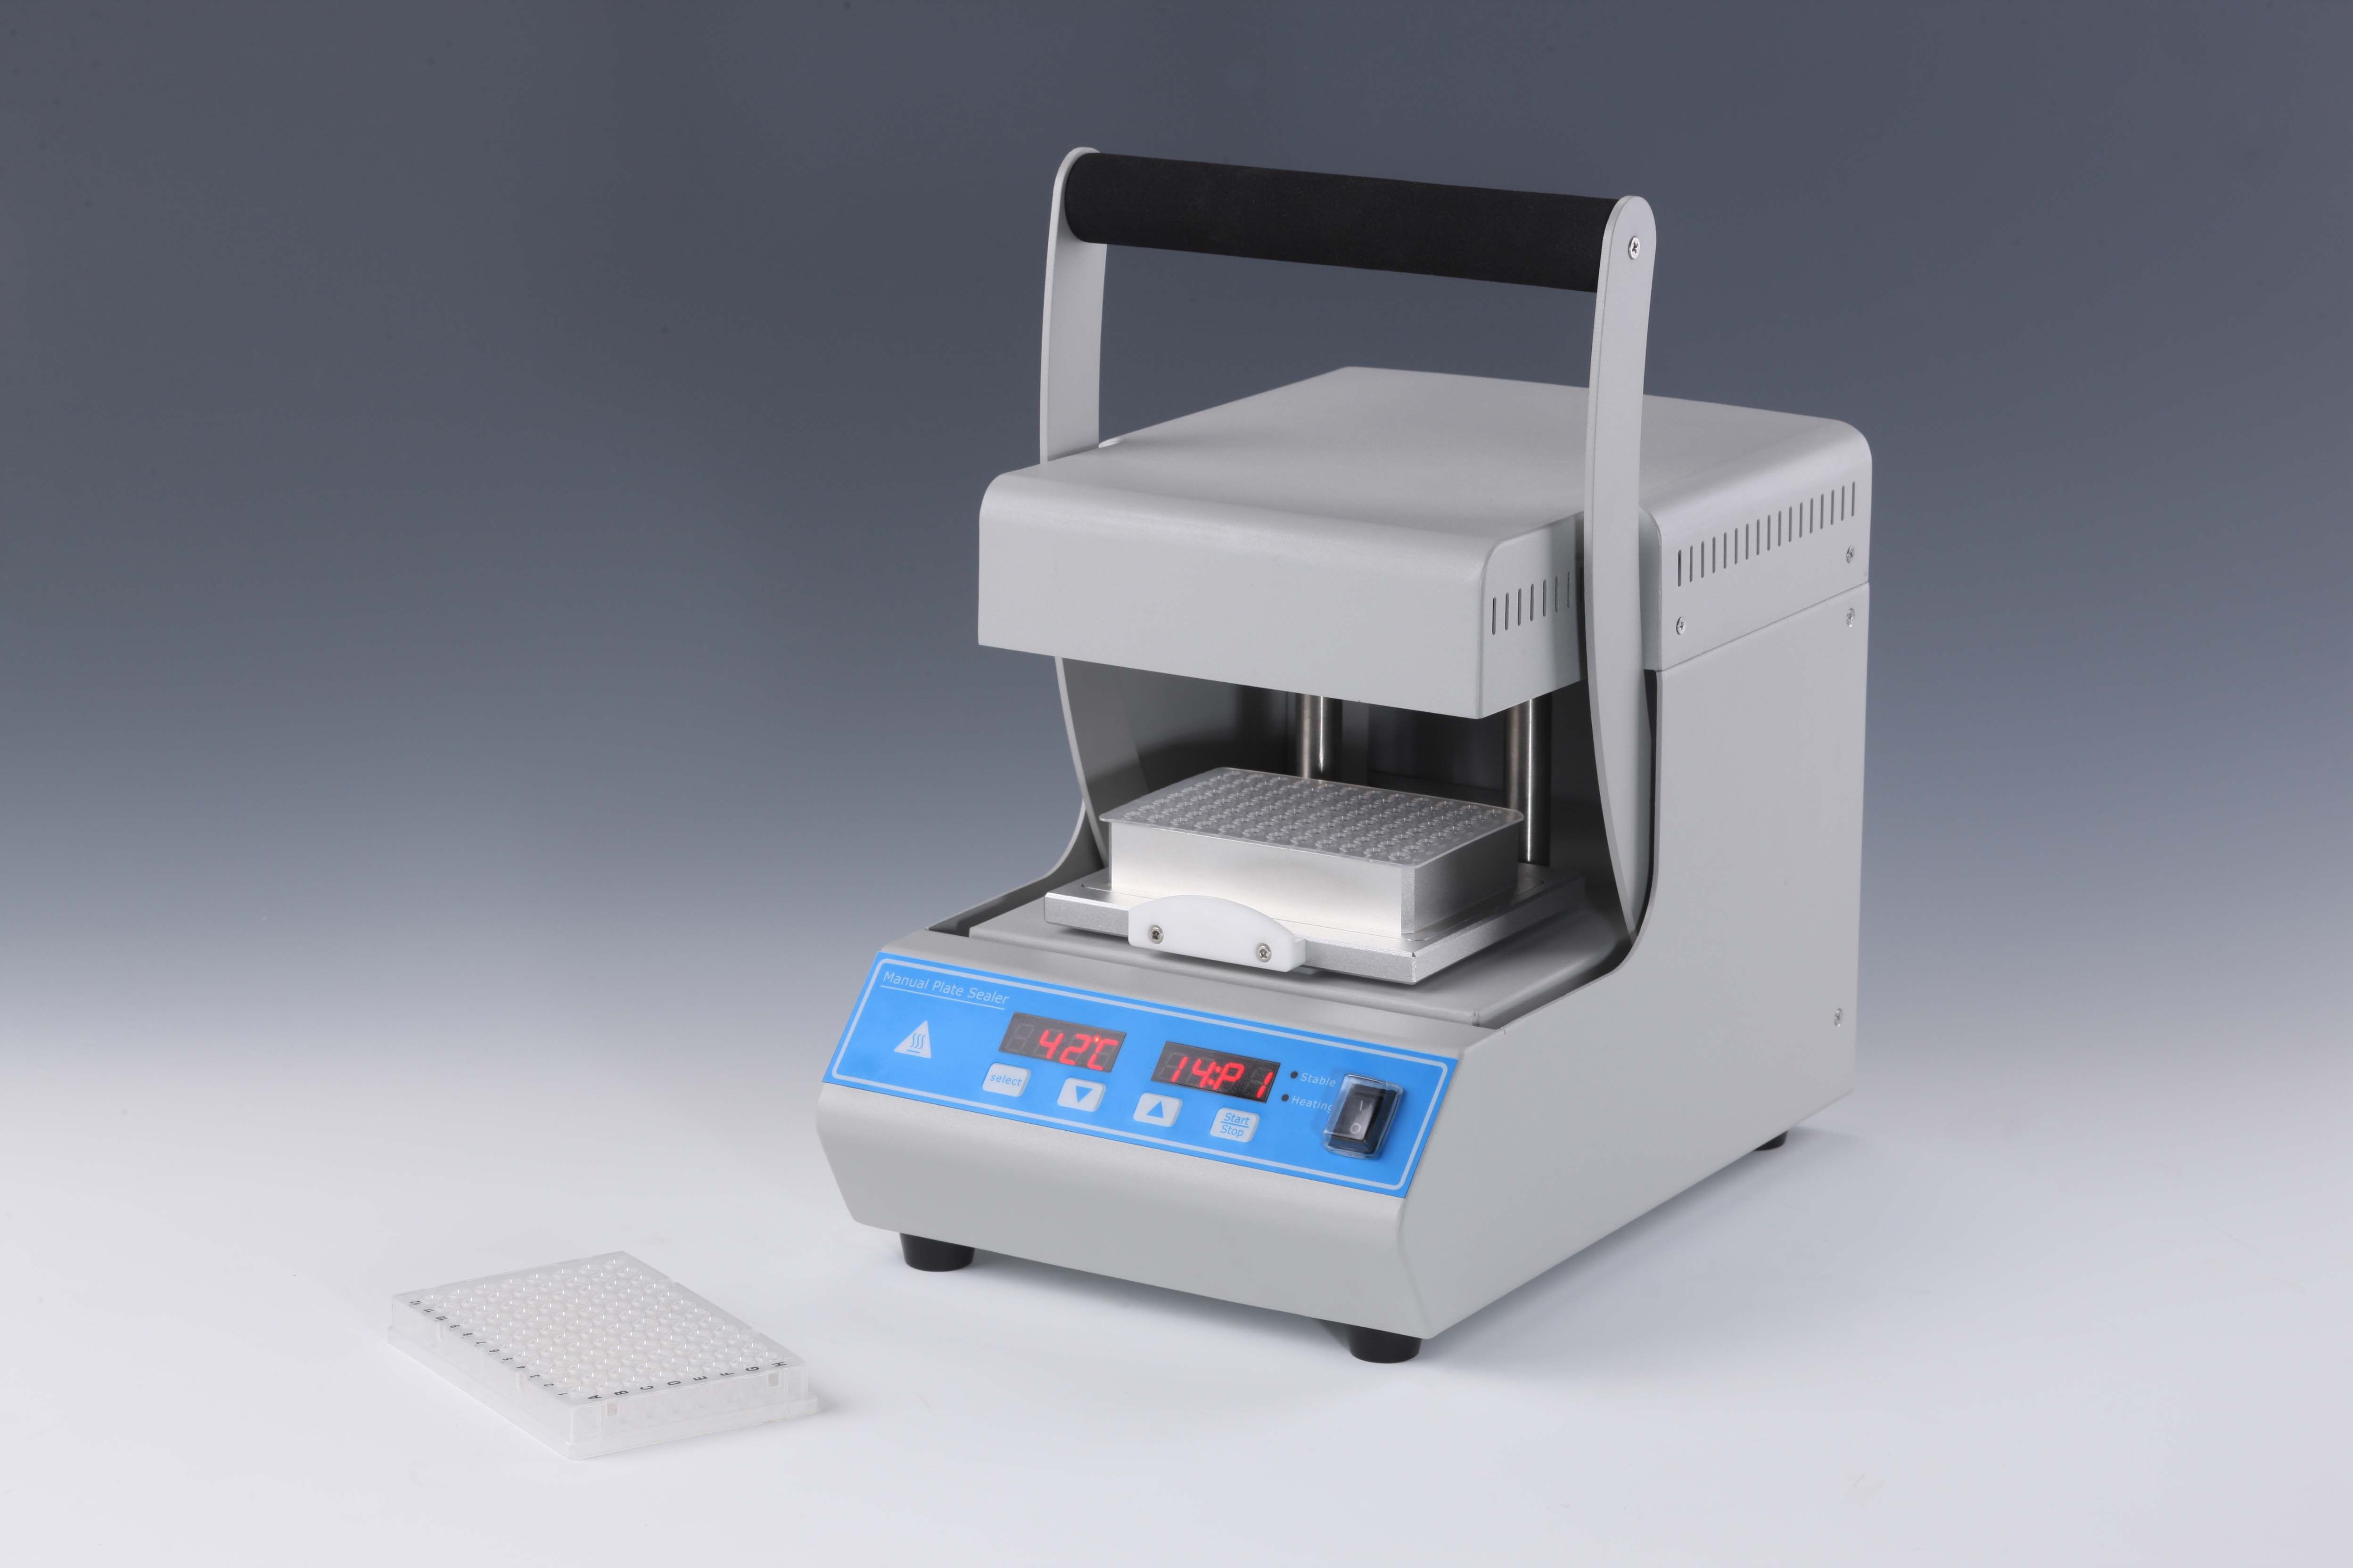
Description:
MSP200 Manual Plate Sealer is used for sealing a wide variety of microplates (Elisa, cell culture, PCR and deep-well plates) to store samples, prevent evaporation and minimize contamination. It is applicable for a variety of heat seals, meeting any laboratory application, including PCR, coulorimetric, fluorescence, long term storage.

Features:：
- Rapid heating(reaching 170°C in 300seconds)
- Adjustable Sealing Temperature: 80°C ~200°C
- Applicable for different micro plates and heat seals.
- Precise temperature, timing and pressure for consistent sealing.
- Unique drawer type sliding platform, easy access to micro plates.
- Economic; easy to operate.
- Over-heating protection device is included.

Parameters
Sealing temperature | 80°C ～200°C
Temperature accuracy | ±1°C
Sealing time | 0.5s～99s(within 10s, increment of 0.1s; above 10s, increment of 1s)
Seal plate height | 9~48mm
Power | 400W
Dimension(D×W×H)mm | 324×216×353
Weight(kg) | 11kg

